Credit Card Fraud Detection Using Machine Learning Techniques

Name: May Assad Nassar

ID Number: 2301212473

1. Introduction
Credit card fraud has become one of the most serious challenges facing financial institutions in the digital age. With the rapid growth of online transactions and electronic payment systems, fraudulent activities have increased significantly, leading to major financial losses for both banks and customers. Traditional fraud detection methods often rely on predefined rules and manual monitoring, which are no longer sufficient to detect complex and continuously evolving fraud patterns.
Machine Learning (ML) techniques provide effective solutions for detecting fraudulent transactions by learning patterns from historical data and identifying abnormal behavior. In this project, machine learning techniques are applied to detect credit card fraud and evaluate their effectiveness. More than one model is implemented and compared in order to analyze their performance on highly imbalanced data. Specifically, Logistic Regression and Isolation Forest are used to classify and identify fraudulent transactions.

2. Dataset Description
The dataset used in this project is the Credit Card Fraud Dataset, which is publicly available on Kaggle and originally provided by the UCI Machine Learning Repository. The dataset contains credit card transactions made by European cardholders over a two-day period.

Dataset Characteristics:
- Total number of transactions: 284,807
- Fraudulent transactions: 492
- Normal transactions: 284,315
This dataset is highly imbalanced, which makes fraud detection a challenging task for traditional classification models.

Features:
- V1 – V28: Principal components obtained using PCA to protect sensitive customer information
- Amount: Transaction amount
- Class: Target variable
  - 0 → Normal transaction
  - 1 → Fraudulent transaction
The main objective of using this dataset is to build a model capable of accurately identifying fraudulent transactions despite the severe class imbalance.

3. Data Preprocessing
Before training the machine learning models, several preprocessing steps were applied to ensure data quality and improve model performance.

Steps Taken:
1.Handling Missing Values
The dataset does not contain missing values; therefore, no imputation was required.
2.Feature Scaling
The Amount feature was scaled using StandardScaler to normalize the data and improve model convergence. Other features were already scaled due to the use of PCA.
3.Handling Class Imbalance
Due to the rarity of fraudulent transactions, evaluation metrics such as precision, recall, and F1-score were emphasized rather than relying solely on accuracy.
4.Train-Test Split
The dataset was split into 80% training data and 20% testing data using stratified sampling to ensure that the class distribution remained consistent across both sets.

4. Exploratory Data Analysis (EDA)
Exploratory Data Analysis (EDA) was performed to better understand the dataset and identify patterns related to fraud detection.

Key Observations
- Fraudulent transactions represent less than 0.2% of the dataset.
- The dataset shows a severe imbalance between normal and fraudulent transactions.
- Visualization of class distribution clearly highlights the imbalance problem.
EDA confirmed the need for specialized techniques, such as anomaly detection models, in addition to traditional classification methods.

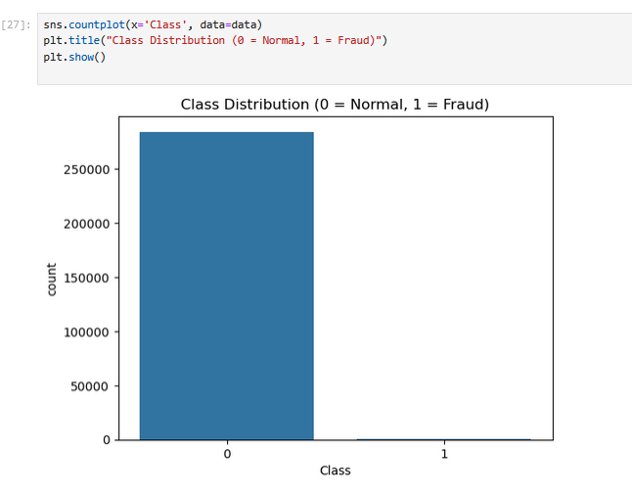

5. Model Implementation
Two machine learning models were implemented and compared in this project.

5.1 Logistic Regression
Logistic Regression was used as a baseline classification model due to its simplicity and interpretability. It is suitable for binary classification problems and helps in understanding the relationship between features and the target variable.
In this project, the Logistic Regression model was trained using balanced class weights to reduce the impact of class imbalance and improve the detection of fraudulent transactions.

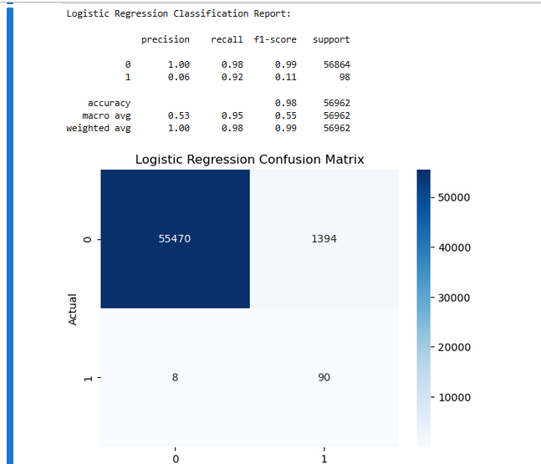

5.2 Isolation Forest
Isolation Forest is an unsupervised machine learning algorithm specifically designed for anomaly detection. It works by isolating observations that differ significantly from the majority of the data.
Isolation Forest is particularly effective for detecting rare events such as credit card fraud. In this project, the contamination parameter was set based on the percentage of fraudulent transactions in the dataset to improve anomaly detection accuracy.
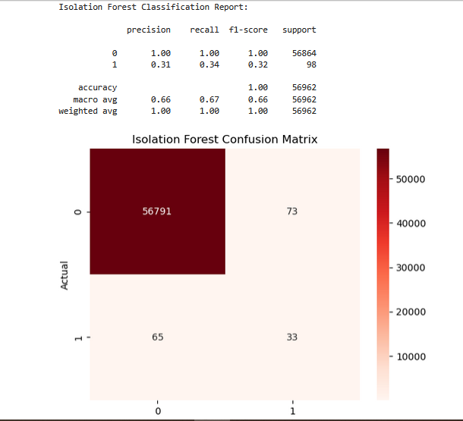

6. Model Evaluation
Because the dataset is highly imbalanced, accuracy alone is not a reliable evaluation metric. Therefore, the following evaluation metrics were used:
- Precision: Measures how many detected frauds are actually fraudulent
- Recall: Measures how many actual fraud cases were correctly detected
- F1-score: Harmonic mean of precision and recall
- Confusion Matrix: Visual representation of prediction results
- ROC Curve and AUC: Measure the overall classification performance
ROC AUC was calculated for both models to compare their ability to distinguish between fraudulent and normal transactions.
Results Summary:
1. Logistic Regression showed reasonable performance; however, its recall for fraudulent transactions was lower compared to Isolation Forest.
2. Isolation Forest achieved higher recall in detecting fraudulent transactions, making it more effective for anomaly detection in highly imbalanced datasets.
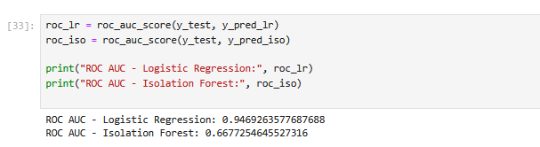

7. Ethical Considerations
The use of machine learning in fraud detection raises several ethical concerns that must be carefully considered:
Privacy
Financial transaction data is highly sensitive and must be protected to prevent misuse.
False Positives
Incorrectly classifying legitimate transactions as fraud may inconvenience customers and affect trust.
Bias and Fairness
Models trained on biased data may unfairly target specific behaviors or users.
Transparency
Financial institutions should ensure that AI systems are explainable and accountable.
Ethical AI practices are essential to maintain fairness, security, and public trust.

8. Results and Discussion
The experimental results demonstrate that machine learning techniques can effectively detect fraudulent credit card transactions. Logistic Regression provides a simple and interpretable baseline model, while Isolation Forest offers stronger performance in detecting anomalies within highly imbalanced datasets.
Despite the promising results, challenges such as evolving fraud strategies and extreme class imbalance continue to limit model performance. Combining multiple models or applying advanced techniques could further enhance detection accuracy.
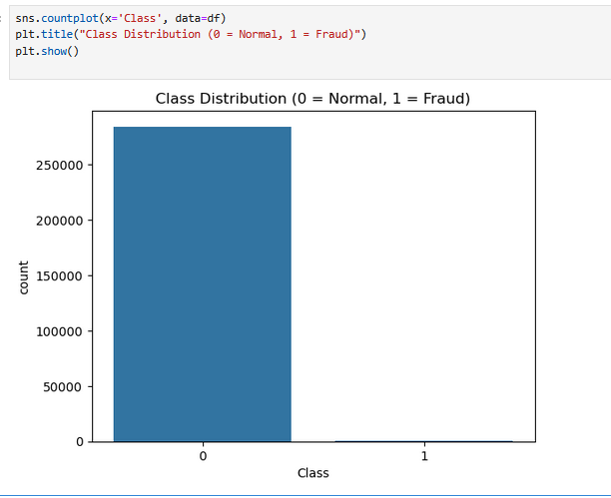

9. Conclusion and Future Work
This project explored the application of machine learning techniques for credit card fraud detection using Logistic Regression and Isolation Forest. The results showed that anomaly detection methods are particularly suitable for identifying rare fraudulent transactions.

Future Improvements
- Applying advanced algorithms such as XGBoost or Neural Networks
- Using resampling techniques like SMOTE
- Implementing real-time fraud detection systems
Machine learning remains a powerful tool in combating financial fraud and improving transaction security.
9. Use of AI Tools
ChatGPT was used as an AI-assisted tool to organize ideas, improve academic writing, and explain machine learning concepts. All data analysis and model implementation were carried out by the author in Python

References (APA Style)
- Dal Pozzolo, A., Bontempi, G., Snoeck, M., & Bontempi, G. (2015). Adversarial drift detection in fraud detection. IEEE Transactions on Neural Networks and Learning Systems, 26(8), 1801–1814. https://doi.org/10.1109/TNNLS.2014.2372010

- Kaggle. (2016). Credit card fraud detection dataset. Kaggle. https://www.kaggle.com/datasets/mlg-ulb/creditcardfraud

- Pedregosa, F., Varoquaux, G., Gramfort, A., Michel, V., Thirion, B., Grisel, O., … Duchesnay, É. (2011). Scikit-learn: Machine learning in Python. Journal of Machine Learning Research, 12, 2825–2830.

- Scikit-learn Documentation. (2024). Isolation Forest. https://scikit-learn.org/stable/modules/generated/sklearn.ensemble.IsolationForest.html

- Scikit-learn Documentation. (2024). Logistic Regression. https://scikit-learn.org/stable/modules/generated/sklearn.linear_model.LogisticRegression.html

- UCI Machine Learning Repository. (2016). Credit card transactions dataset. University of California, Irvine. https://archive.ics.uci.edu

